How to reset ESXi root password using gparted

First step, we need to download and bootable gparted Live OS and mount that ESXi server

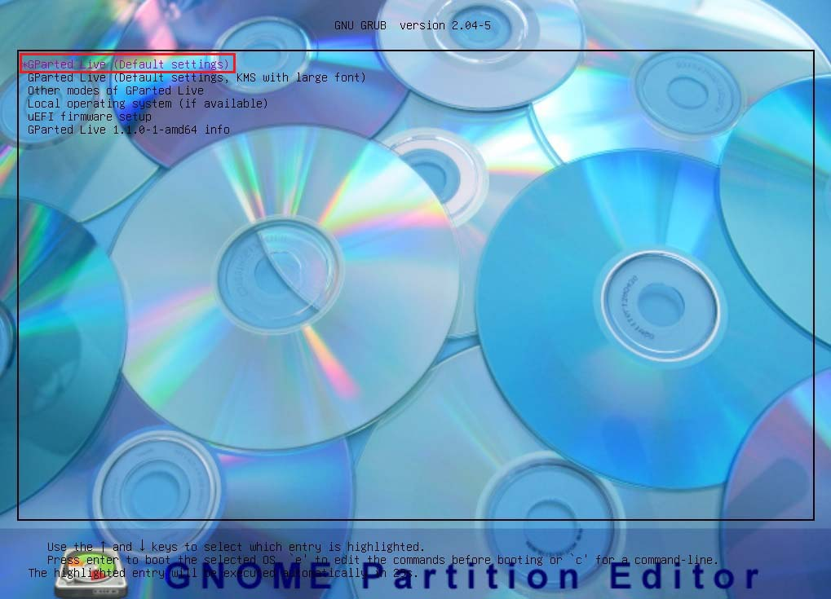

Second step, Go live open step by step this OS

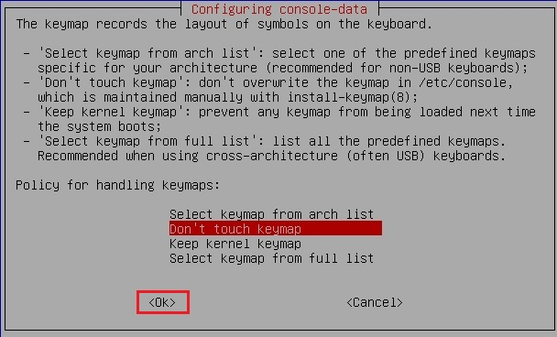

Choose Language,

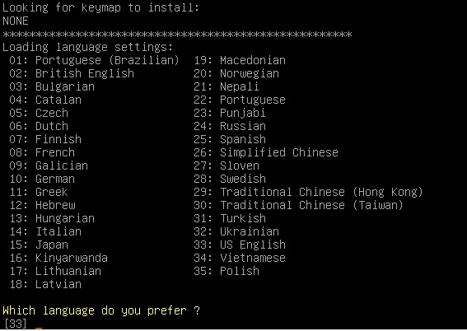

After that you will see Diskspace and check for root directory path

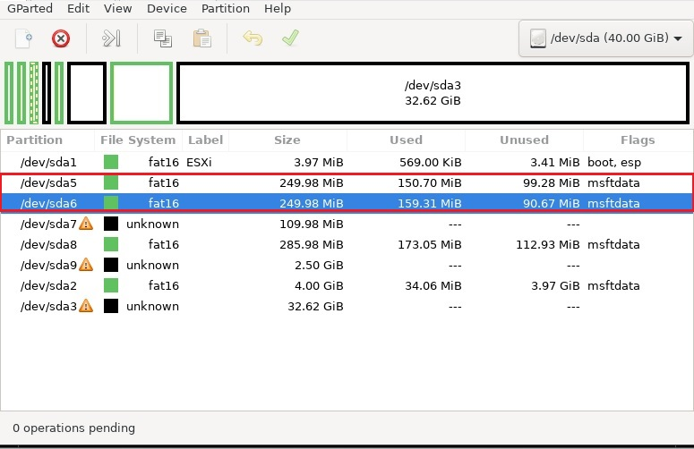

And temp mount this path on gparted,

# sudo su

# mkdir /boot /temp

# mount /dev/sda5 /boot

# cd /boot

# cp state.tgz /temp

# cd /temp

# tar -xf state.tgz

# tar -xf local.tgz

# rm *.tgz

# cd etc

# vi shadow

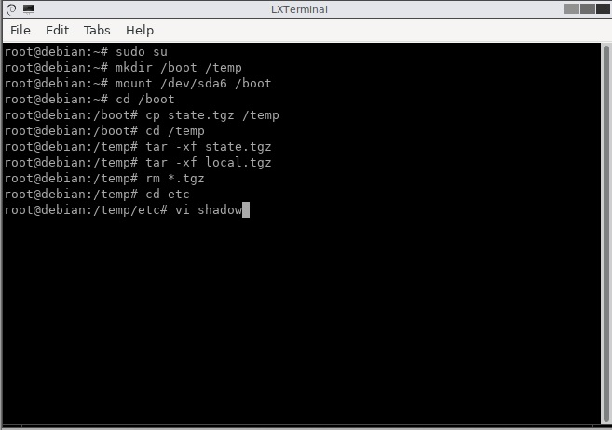

Delete file in root user

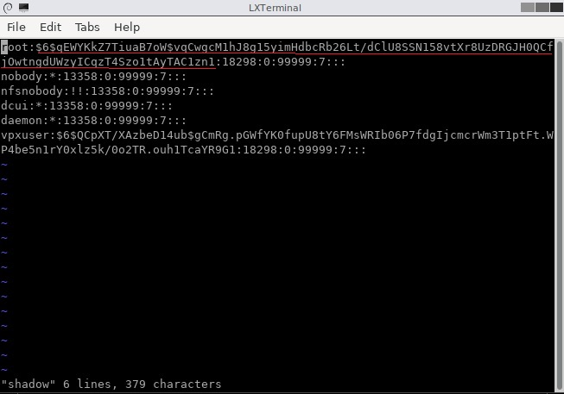

Qfwtwg

Andthan we need to mount and this tgz file on boot file

# cd ..

# tar -cf local.tgz etc/

# tar -cf state.tgz local.tgz

# mv state.tgz /boot

# umount /boot

#reboot

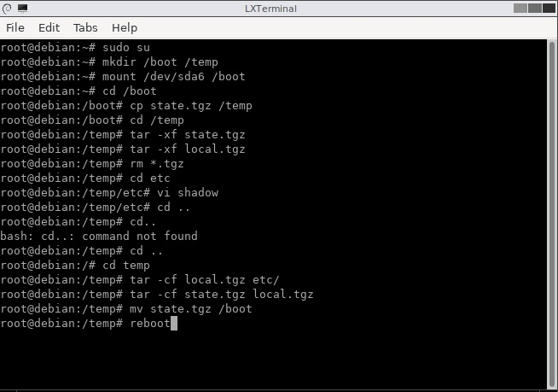

Now got it no need password to login

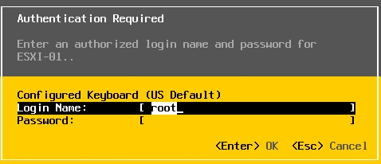

BYE!!!

Tun Lin Aung

18/6/2021